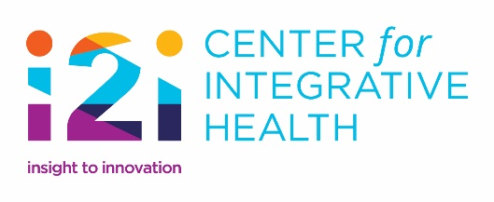

Innovations Awards
2018

Call for Nominations

The i2i Center for Integrative Health is establishing a new awards program – the Innovations Awards. These awards recognize innovation in services and programming to increase integrated, whole person approaches to care. Nominations will be accepted from any individual or from any organization(s) serving those who utilize NC’s publically funded MH/IDD/SUD service system.

Award Categories

Quality Commitment
Organizations that demonstrate commitment to improvement in the quality of service delivery by demonstrating improved treatment and outcomes that result in measureable improvements in the lives of the individuals served.

Technology
Innovative technologies that assist individuals with any of the following: care access, independence, self-care, self-determination or advocacy.

Whole Person Care
Programs or services that demonstrate integrative approaches and address Social Determinants of Health (SDOH) in providing care for individuals with MH/IDD/SUD needs.

Community Inclusion
Initiatives that bring together community partners/stakeholders to promote the inclusion of individuals in their local communities.

Individual and Family Initiatives
Programs or services led by individuals and/or family members to improve the lives of those served in the public MH/IDD/SUD system.

Nominations will be evaluated on the following criteria as applicable:

- Person Centeredness and Whole Person Focus
- Innovation
- Flexibility in service management and empowerment at service delivery level
- Demonstration of positive outcomes
- Accessibility/user friendliness

Deadline for Submission is October 19, 2018

Innovations Awards
2018

Innovations Award Categories – Choose One (X)

__ Quality Commitment
__ Technology
__ Whole Person Care
__ Community Inclusion
__ Individual and Family Initiatives

Nomination:

City: State: Zip:

Contact Person:

Email Address:

Phone:

Directions: When answering the questions below, please describe the way in which your nomination is outstanding and meets the nomination criteria. Try to keep each question’s answers to less than 350 words. Please write your description as if a lay-person is the reader. You may also attach photos, or other materials (up to 3 attachments) to support your nomination.

How to apply: Please email nominations to jean@i2icenter.org with or without attachments to be received no later than October 19, 2018. If you have questions, email Jean Overstreet. The awards will be presented at the i2i Center conference at a reception in Pinehurst, NC on December 6, 2018.

- Please provide an overview of this nomination.

- Please describe how this nomination meets the Award’s Criteria.

- Please describe positive outcomes you have seen as a result of this nomination.

- Please tell us about a consumer and/or family that has been positively impacted by this nomination.

